HMS

CONTENTS

1. Introduction
2. Login
   * 1. Admin
     2. Patient
     3. Staff

3. Register

* + 1. Patient

4. Dashboard

* + 1. Admin
    2. Patient
    3. Staff (Doctor, Nurse, Receptionist)

**ADMIN MODULE :**

LOGIN

Admin needs to login by entering their Username along with the correct password.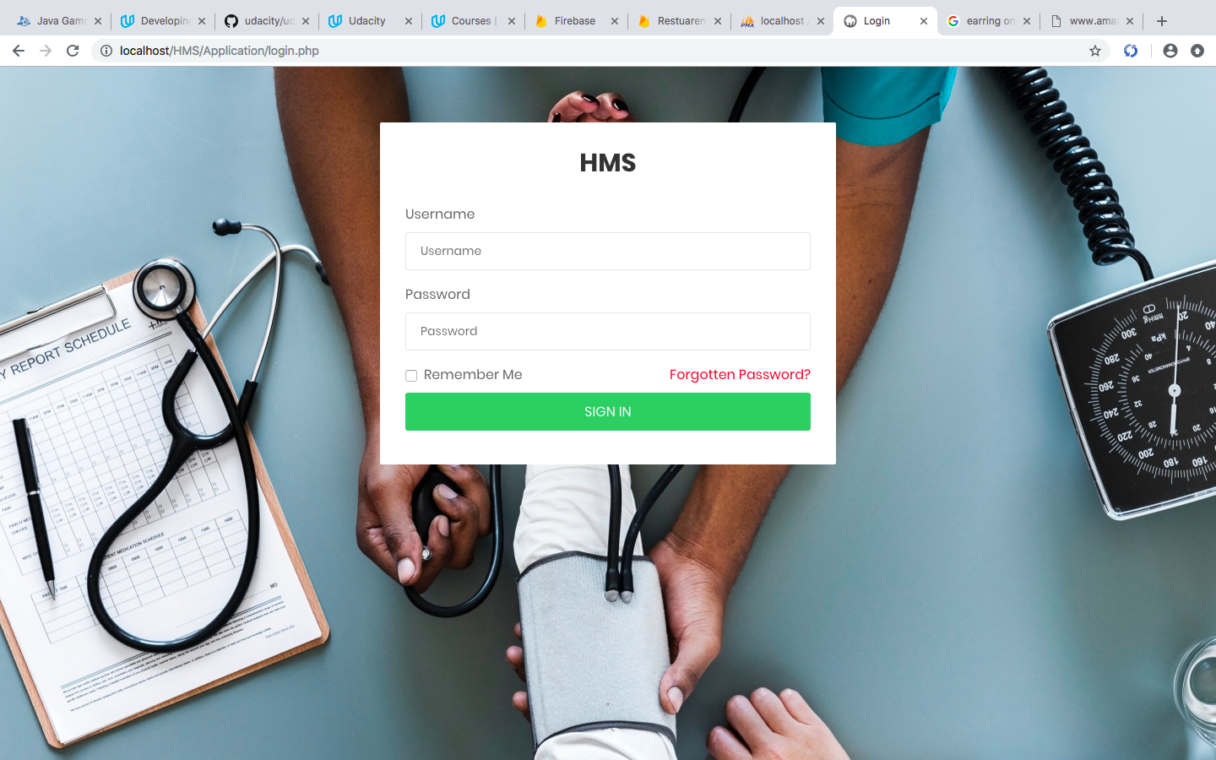

DASHBOARD

After successful login, the Admin is directed to the Admin panel. Here the Admin has various options such as:

* + - Add/Delete Department
    - Add/Delete Doctor
    - Add/Delete Nurse
    - Add/Delete Receptionist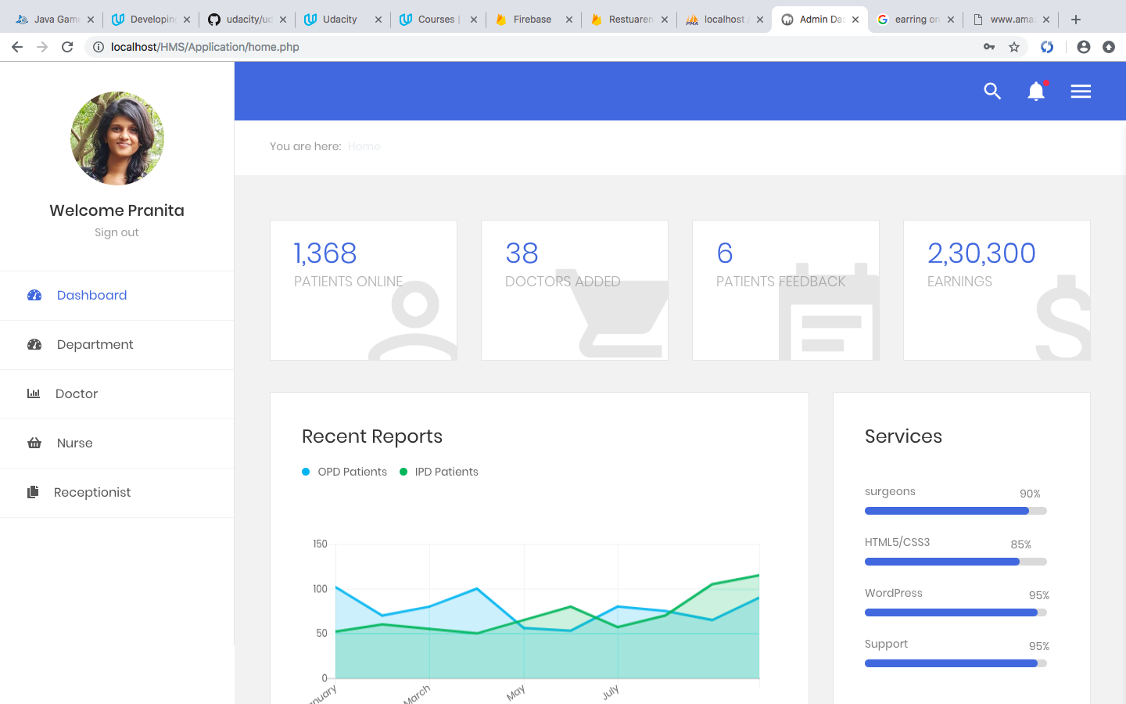

DEPARTMENT LIST

Existing Department names will be displayed on panel, Admin have rights to Add new Department or Delete the Department if they are not existing any more.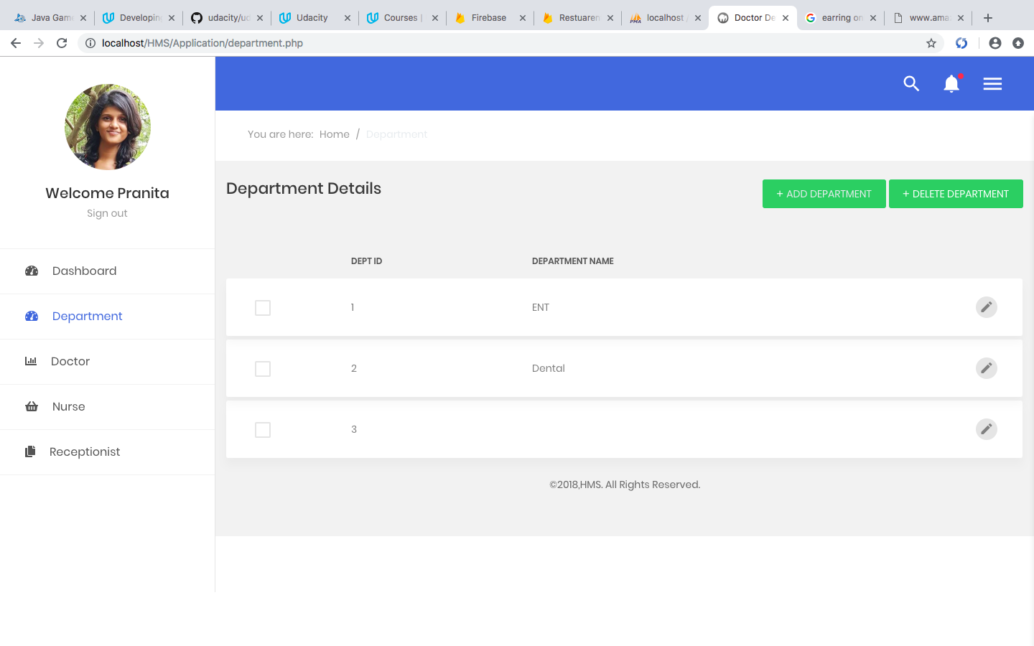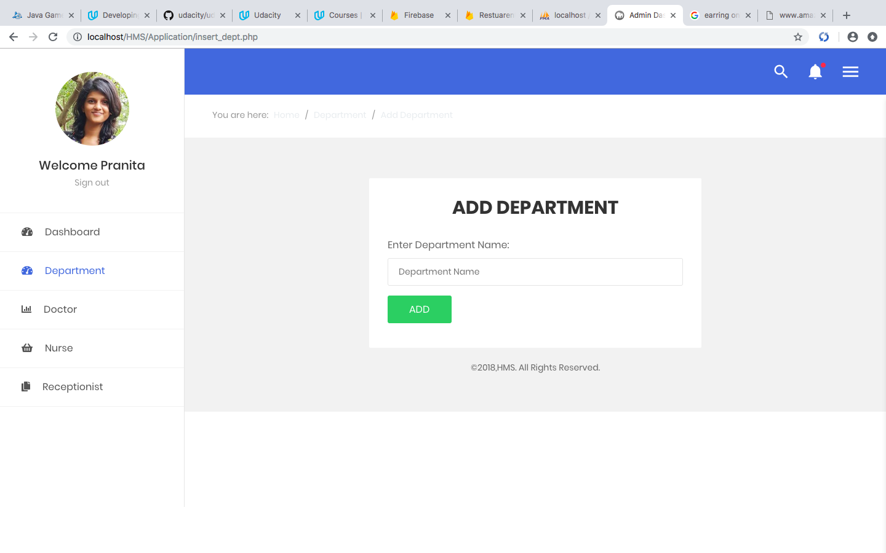

DOCTOR

Existing Doctor names will be displayed on panel, Admin have rights to Add new Doctor once they join or Delete the Doctor if they left.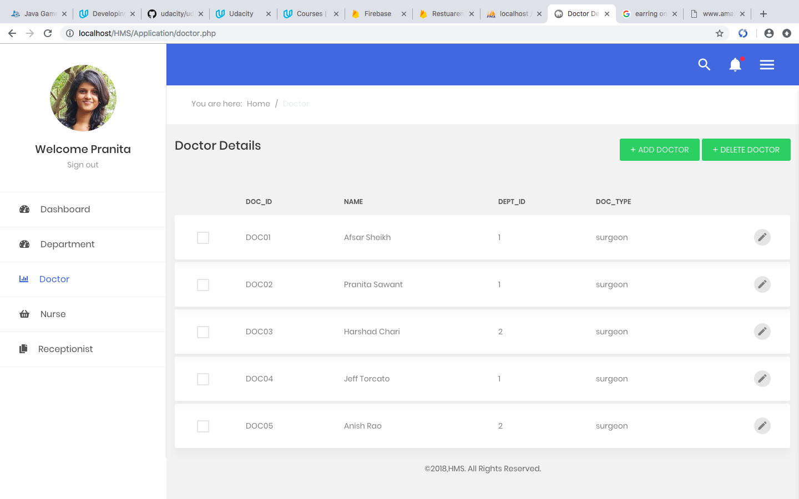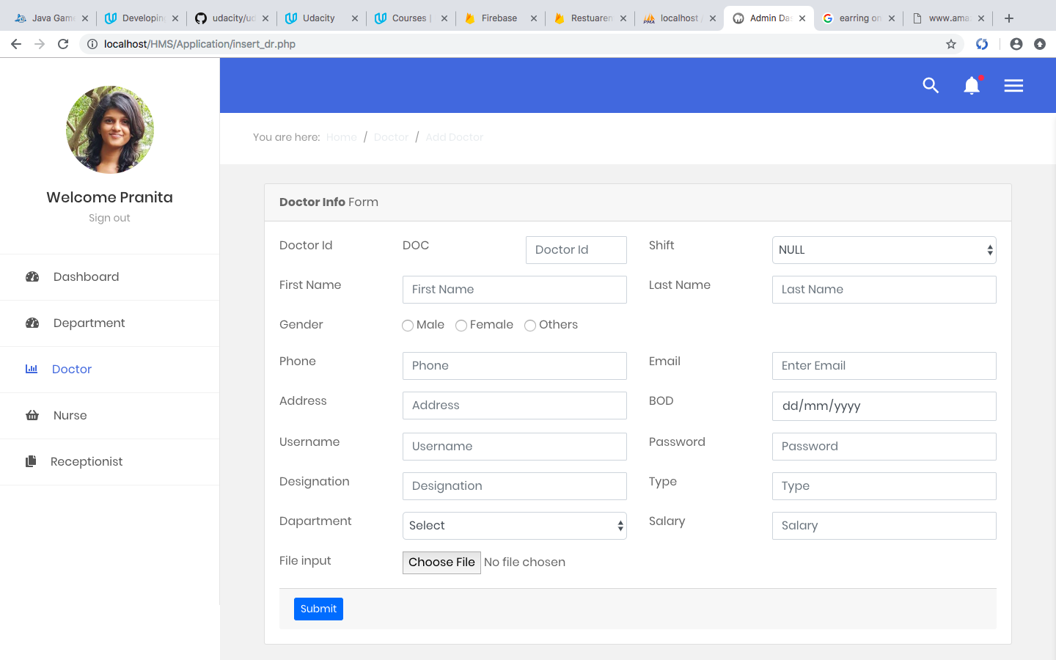

NURSE

Existing nurse names will be displayed on panel, Admin have rights to Add new nurse once they join or Delete the nurse if they left.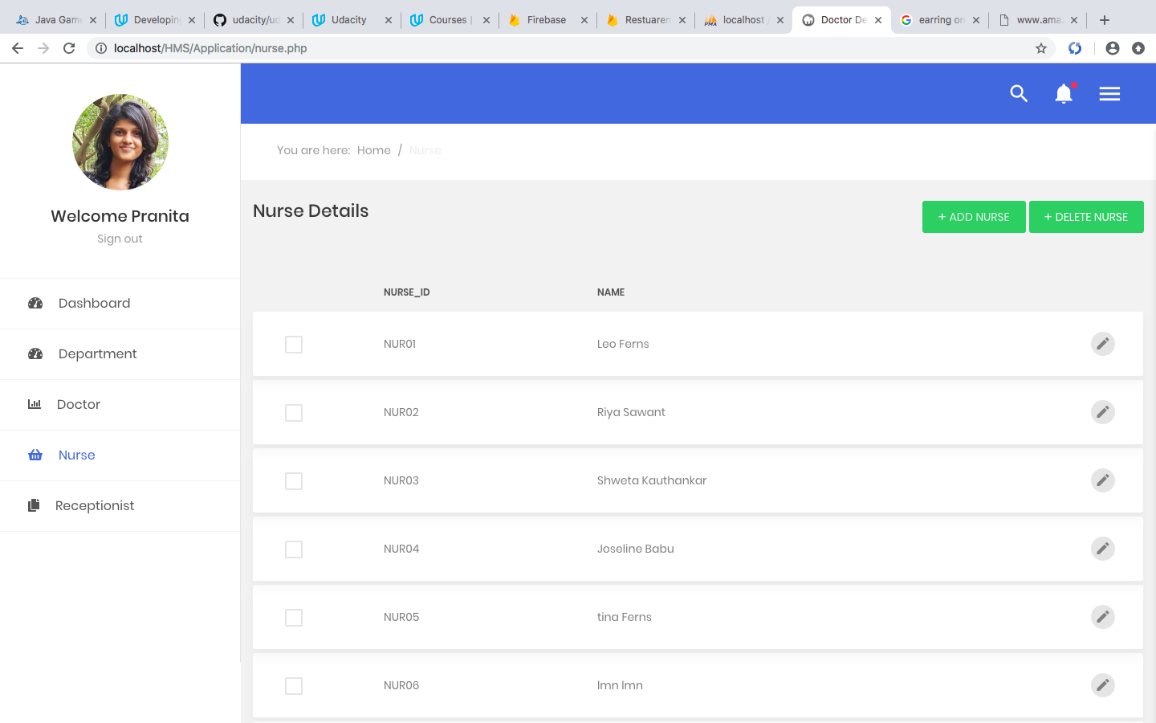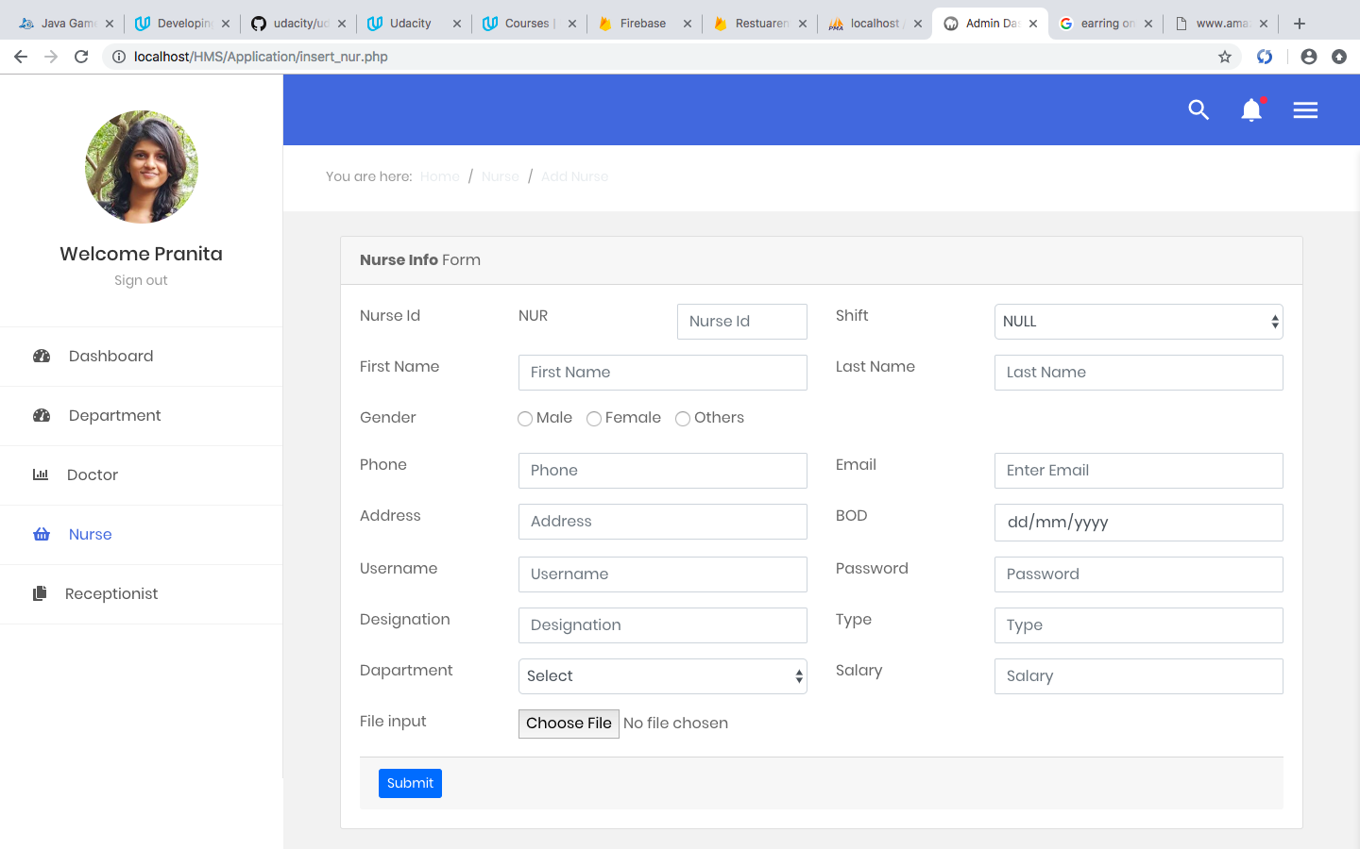

RECEPTIONIST

Existing receptionist names will be displayed on panel, Admin have rights to Add new receptionist once they join or Delete the receptionist if they left.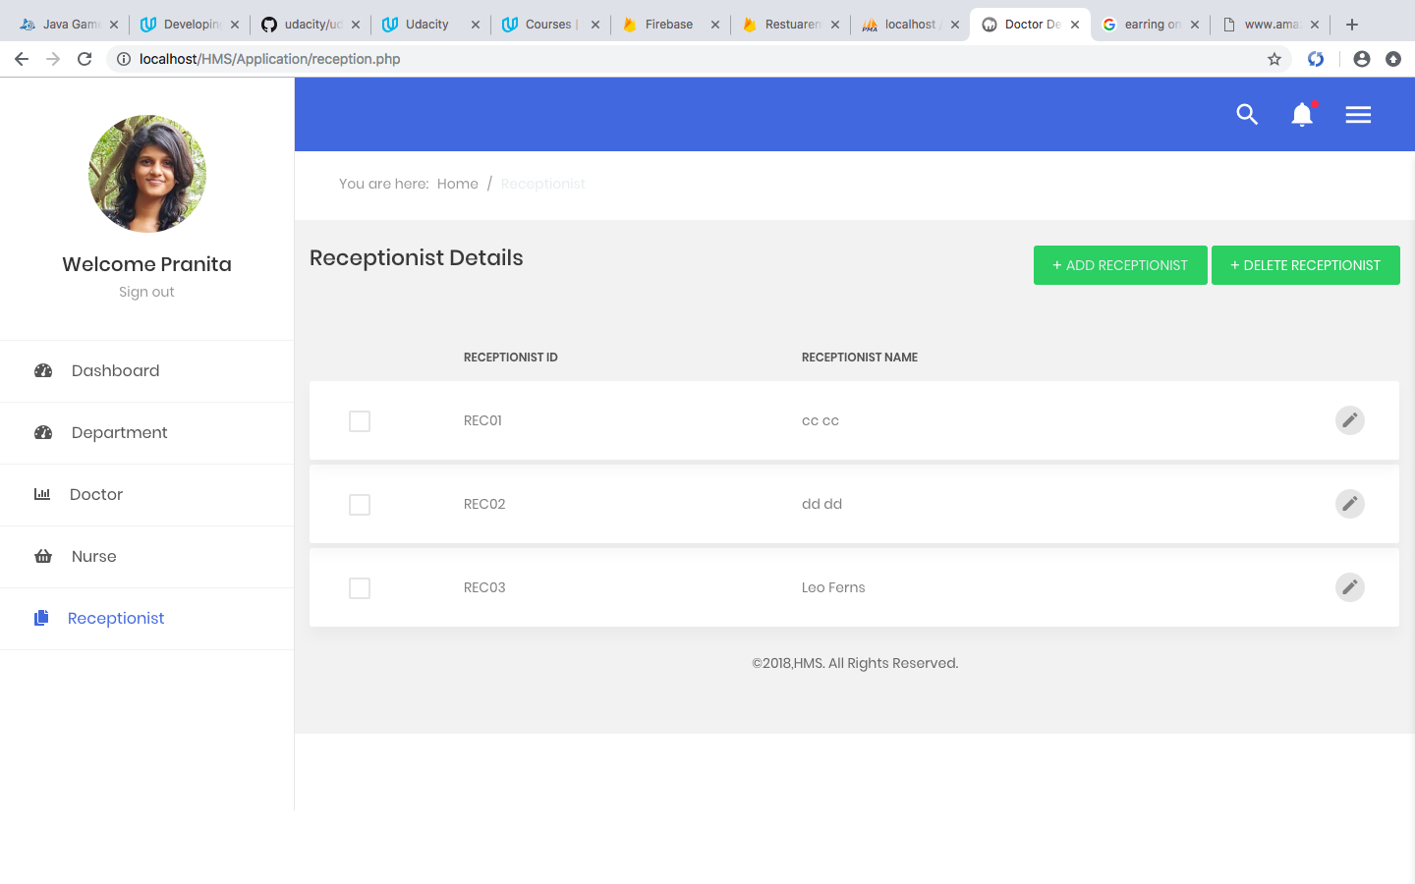

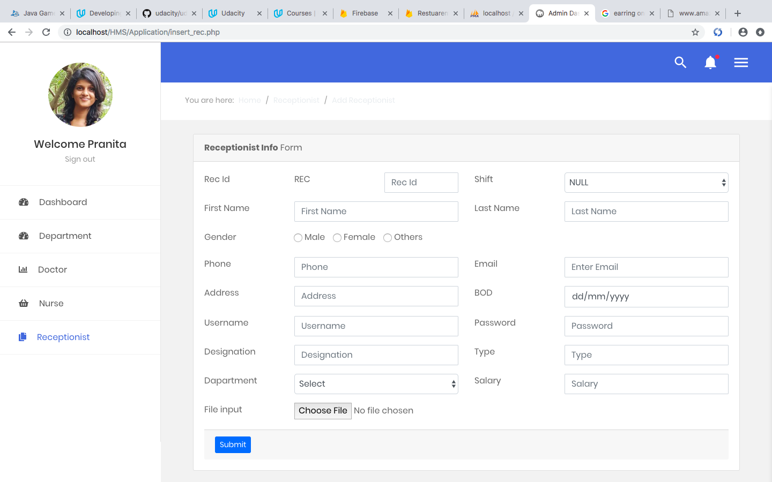

**PATIENT MODULE :**

HOME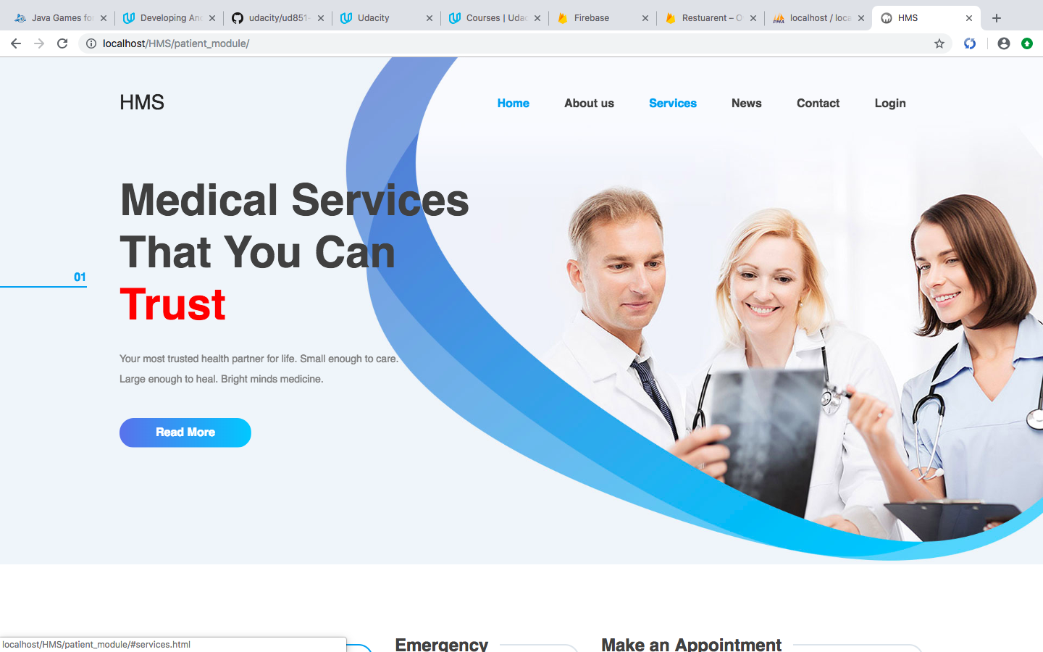

REGISTRATION

In order to make use of HMS services the new Patients need to register themselves first.

Registration can be done by entering the details such as name, email, phone, password and so on.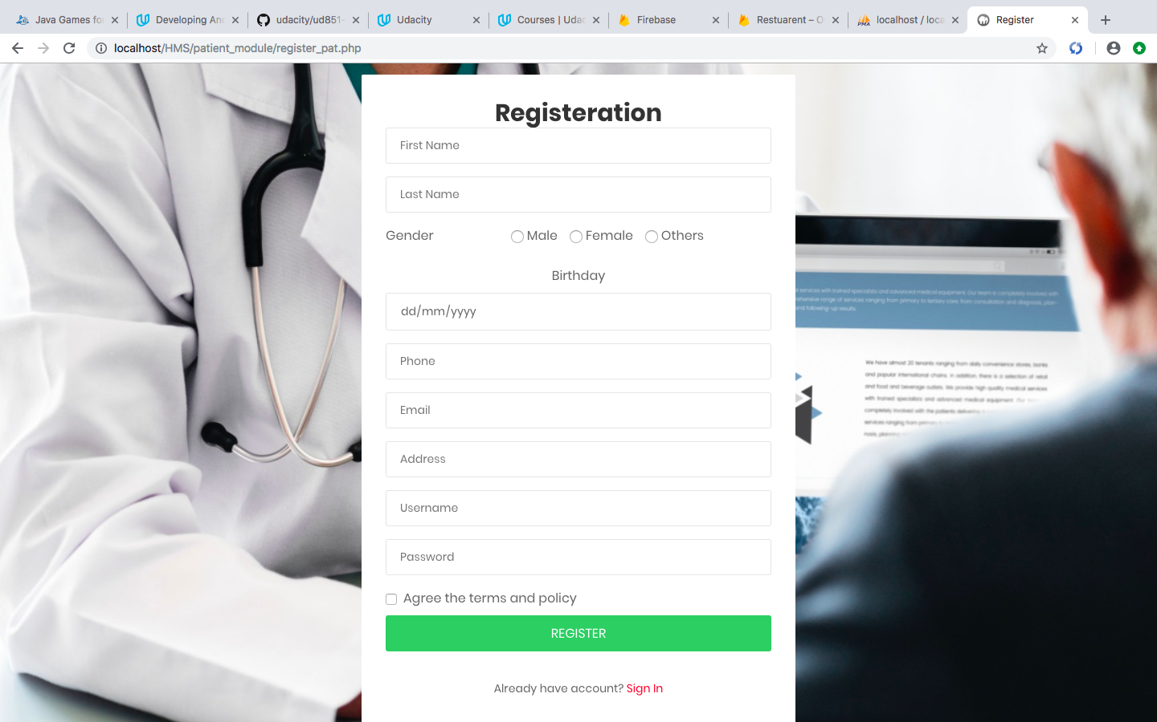

LOGIN

Patient needs to login by entering their email-id along with the correct password.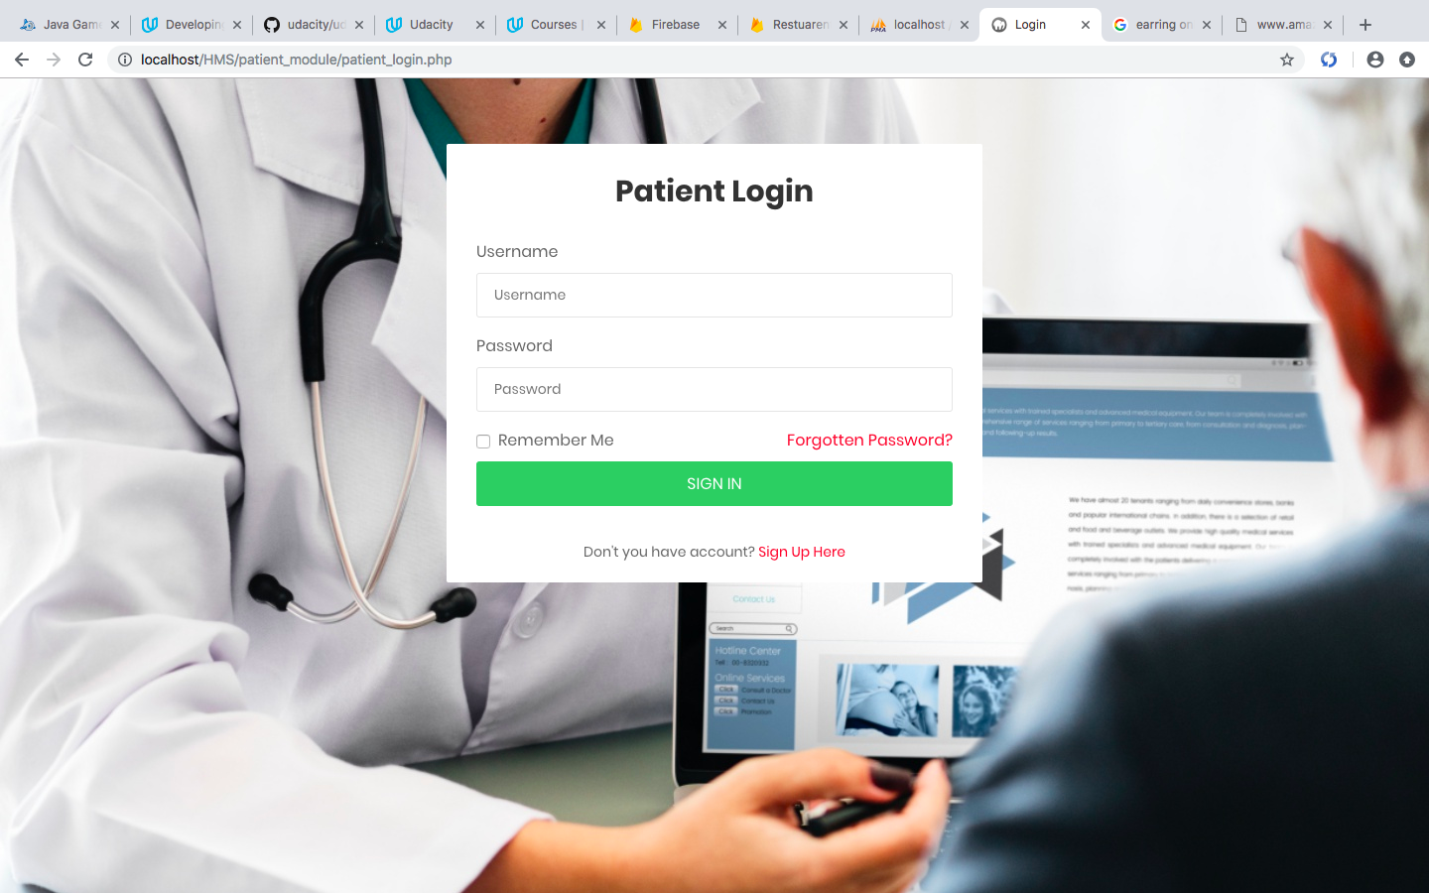

BOOK APPOINTMENT

To book an appointment user have to select department name, based on that doctor list will be displayed select one doctor from that list along with89 date of appointment.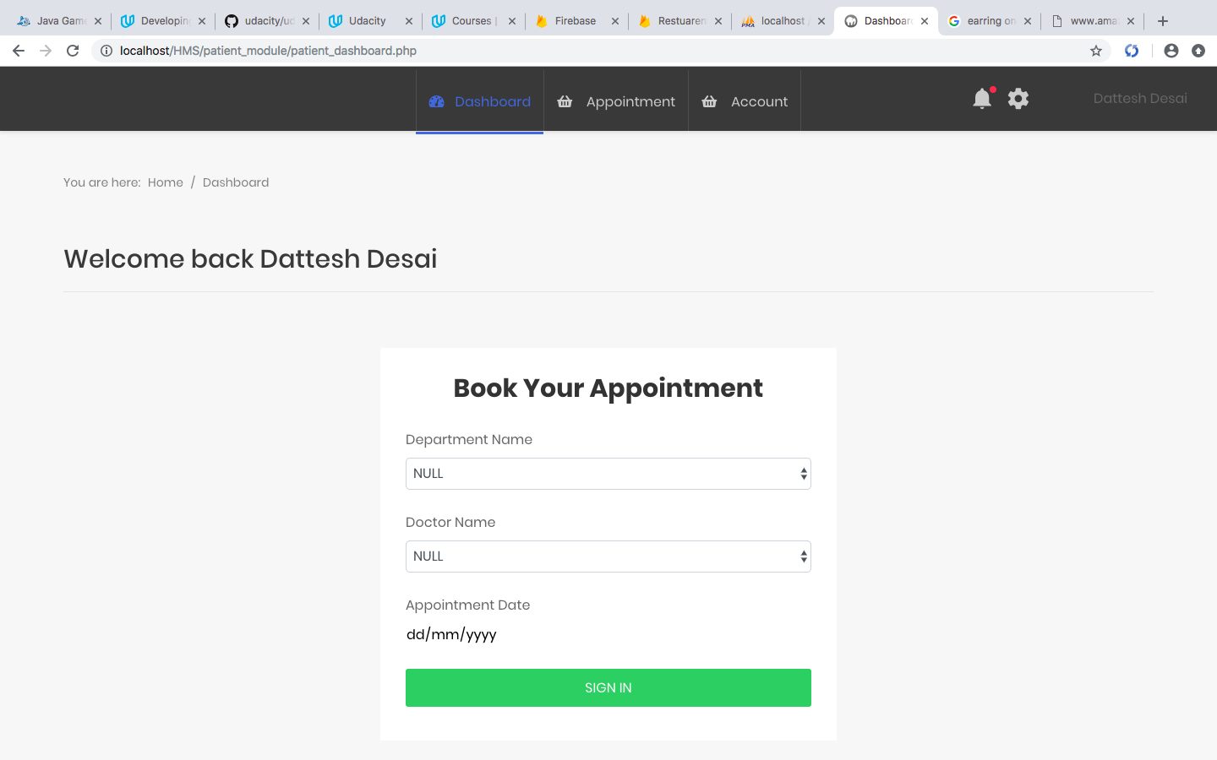

**STAFF MODULE :**

LOGIN

All staff (i.e. Doctor, Nurse, Receptionist) have common login, but each one will have different dashboard that will be decided on Username.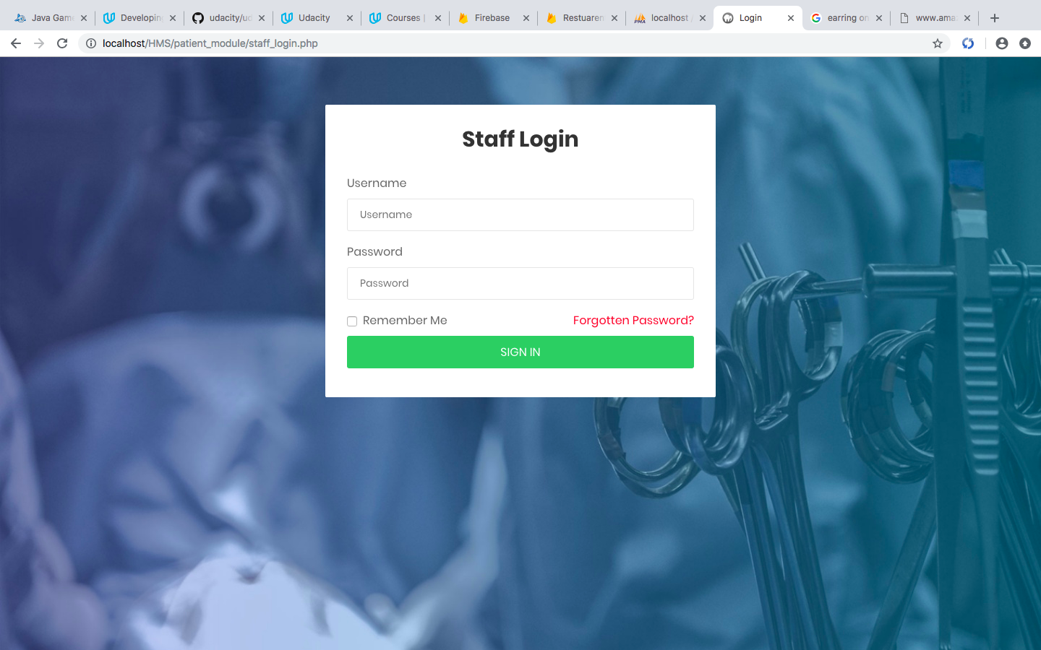

STAFF - - - -> DOCTOR

Doctor dashboard will open with list of appointment he is supposed to attend.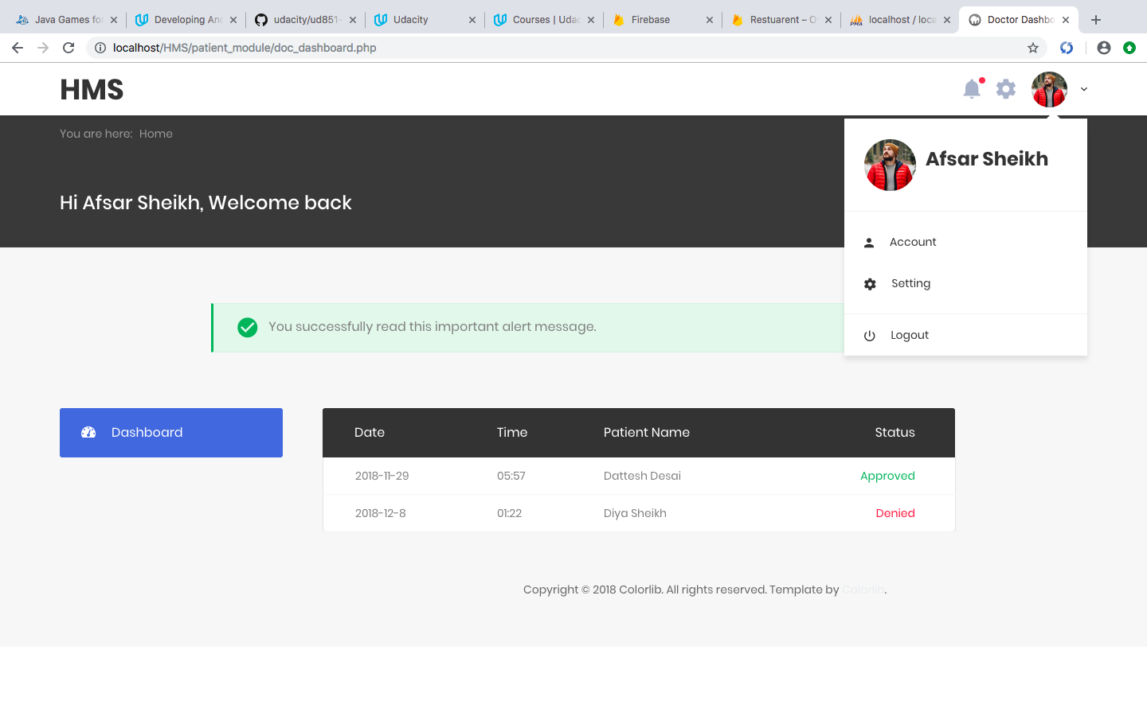

NOTE: Similar with other staff with different dashboard.